SQL Advanced Programming
Group Project – Week 4: Procs B, C, & E / Recipe Index / Delete Procs

- Test 1 - Item 1 / Proc B: Selecting ingredients and tallying up cost per recipe, 141 rows

EXEC spN_RecipeDetails;
GO
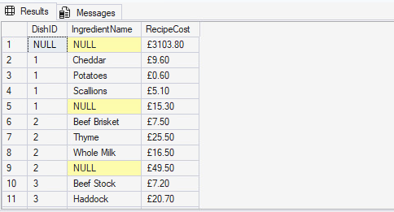
- Test 2 – Item 1 / Proc C: Selecting Dishes and their ingredients, 100 Lines
EXEC spN_DishDetails
GO
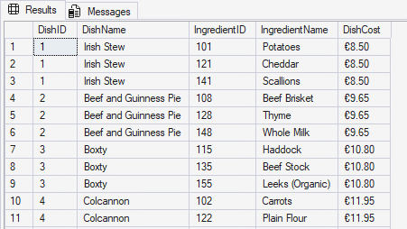
- Test 3 – Item 1 / Proc E: Selecting customer details and formatting name, 100 lines
EXEC spN_CustomerDetails
GO
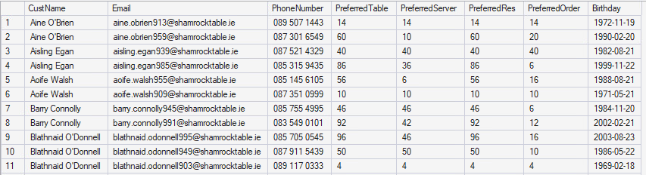

- Test 4 – Item 3 / Delete Proc Charities: Deleting the charity from the table. Accepts the ID for the charity
EXEC spN_CharitiesDelete
@CharityID = 9001
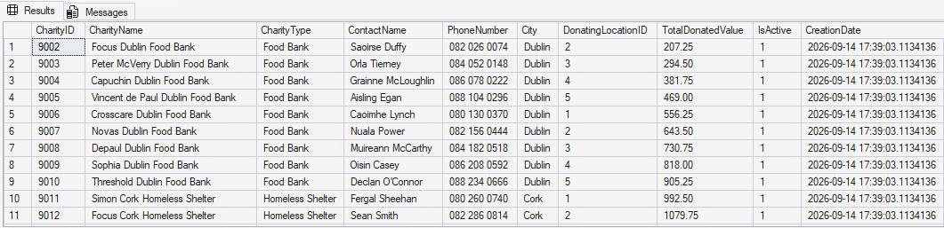

- Test 4 – Item 3 / Delete Proc KitchenDetails: Deleting the details for the kitchen and updating chef and demographic tables accordingly
EXEC spN_KitchenDetailsDelete
@KitchenID = 1,
@LocationID = 1

